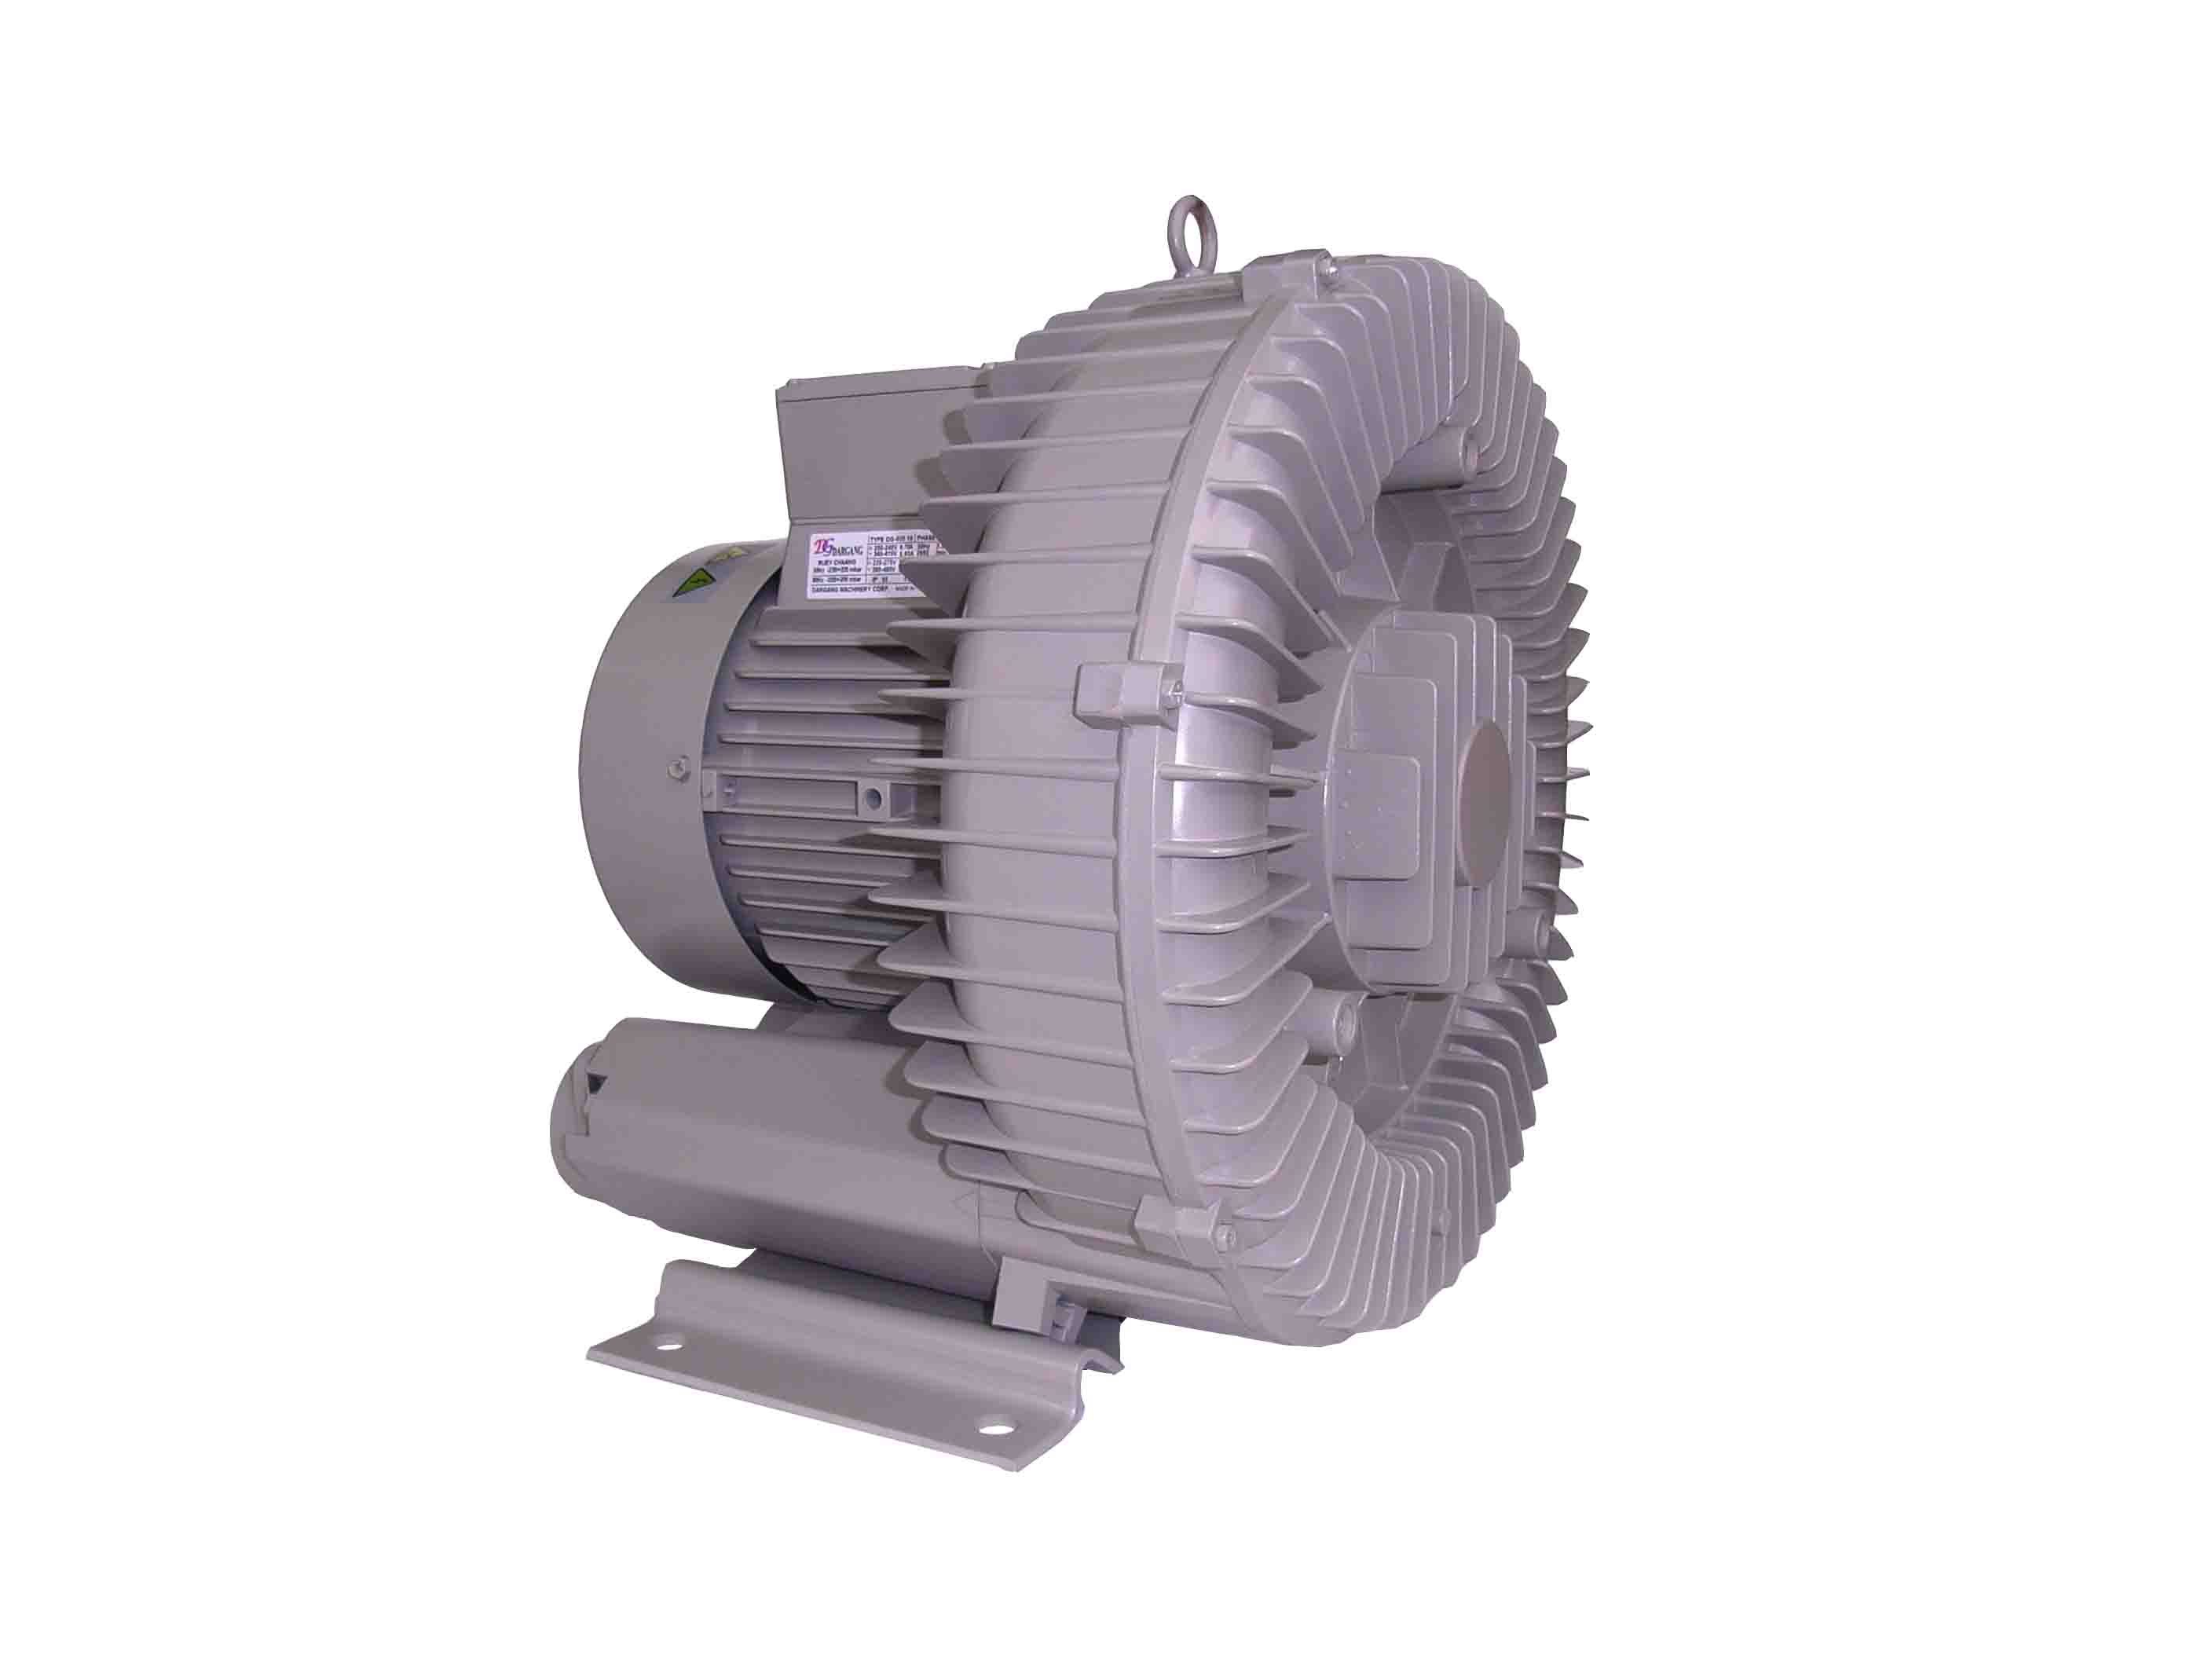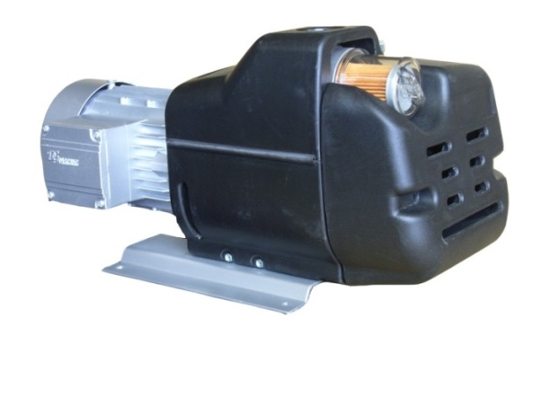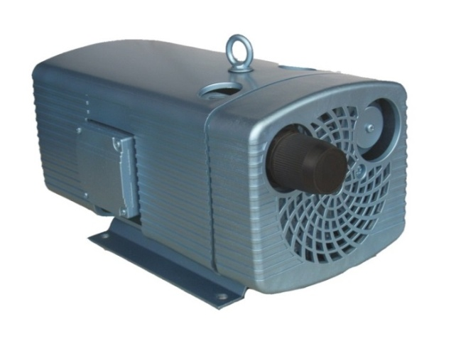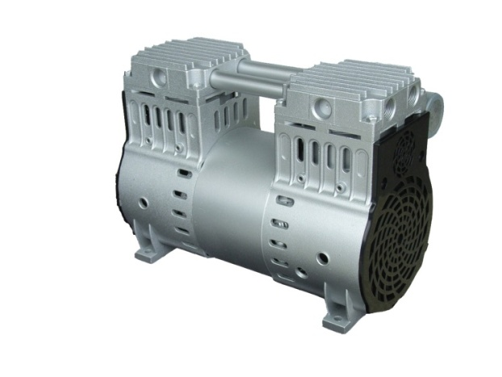

**高 裕 幫 浦 有 限 公 司**

**KAO YU PUMP CO.,LTD**

***Dry running rotary vane乾式真空&壓力泵pressure & vacuum pump***

***Dry running rotary vane vacuum pump***

***VD-V Series***

04

08

04

08

|  |  |  |  |  |
| --- | --- | --- | --- | --- |
| **VD-V** | | | **04** | **08** |
| m³/ h |  | 50Hz | 4.1 | 8.0 |
|  | 60Hz | 4.7 | 9.1 |
| mbar (abs.) ● |  |  | 150 | |
| 3~ |  | 50Hz | 200-240 / 345-415V ± 5% | |
|  | 60Hz | 220-275 / 380-480V ± 5% | |
| 1~ |  |  | 230V ± 10% (50 / 60Hz) | |
| kW (3~) |  | 50Hz | 0.18 | 0.37 |
|  | 60Hz | 0.21 | 0.44 |
| kW (1~) |  | 50Hz | 0.18 | 0.35 |
|  | 60Hz | 0.21 | 0.42 |
| A (3~) |  | 50Hz | 1.1 / 0.63 | 1.78 / 1.03 |
|  | 60Hz | 1.1 / 0.63 | 1.70 / 0.98 |
| A (1~) |  | 50Hz | 1.25 | 2.4 |
|  | 60Hz | 1.30 | 2.7 |
| min¯¹ |  | 50Hz | 2800 | 2780 |
|  | 60Hz | 3200 | 3250 |
| dB(A) |  | 50Hz | 59 | 58 |
|  | 60Hz | 61 | 61 |
| kg |  | 3~/1~ | 7 | 10 |

**VD-V04 ~ 08尺寸圖 / Dimensions**

圖中 (xx. )尺寸為VD-V04

**\*本公司保有設計變更之權利，恕不另行通知。**

**\*We reserve the right to change the design without notice.**

***Dry running rotary vane vacuum pump***

***VD-V Series***

|  |  |  |  |  |  |  |
| --- | --- | --- | --- | --- | --- | --- |
| **VD-V** | | | **10** | **16** | **25** | **40** |
| m³/ h |  | 50Hz | 11 | 16.6 | 25.4 | 42.0 |
|  | 60Hz | 13 | 20.0 | 30.5 | 50.0 |
| mbar (abs.) ● |  |  | G:\VD-V40.jpg150 | | | |
| 3~ |  | 50Hz | 200-240 / 345-415V ± 5% | | | |
|  | 60Hz | 220-275 / 380-480V ± 5% | | | |
| 1~ |  |  | 230V ± 10% (50 / 60Hz) | | | |
| kW (3~) |  | 50Hz | 0.37 | 0.55 | 0.75 | 1.30 |
|  | 60Hz | 0.45 | 0.65 | 0.90 | 1.50 |
| kW (1~) |  | 50Hz | 0.37 | 0.55 | 0.75 | 1.30 |
|  | 60Hz | 0.45 | 0.65 | 0.90 | 1.50 |
| A (3~) |  | 50Hz | 1.90 / 1.10 | 2.70 / 1.55 | 3.60 / 2.10 | 6.60 / 3.80 |
|  | 60Hz | 1.90 / 1.10 | 2.90 / 1.70 | 4.00 / 2.30 | 6.90 / 4.00 |
| A (1~) |  | 50Hz | 3.20 | 4.5 | 5.60 | 10.00 |
|  | 60Hz | 3.20 | 5.0 | 6.50 | 10.00 |
| min¯¹ |  | 50Hz | 1420 | | | |
|  | 60Hz | 1700 | | | |
| dB(A) |  | 50Hz | 60 | 61 | 64 | 67 |
|  | 60Hz | 61 | 63 | 66 | 69 |
| kg |  | 3~/1~ | 19.3 / 20.6 | 21.5 / 21.8 | 30.5 / 31.5 | 38 / 39 |

60 Hz

m³/h*

50 Hz

m³/h

40

40

25

40

40

25

mbar(abs.)

mbar(abs.)

**VD-V10 ~ 40尺寸圖 / Dimensions**

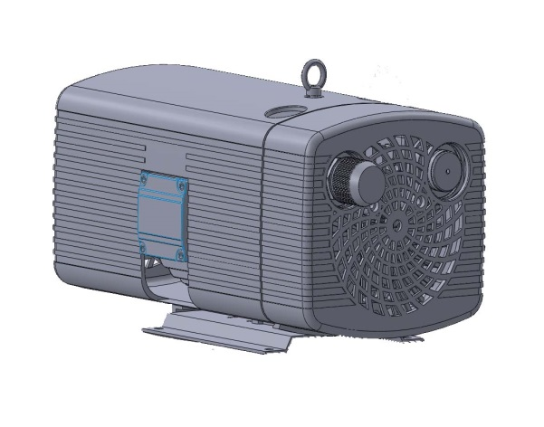



|  |  |  |  |  |  |
| --- | --- | --- | --- | --- | --- |
| **VD-V** | | **10** | **16** | **25** | **40** |
| (mm) | A | 200 | 200 | 200 | 200 |
| B | 225 | 225 | 225 | 225 |
| C | 10 | 10 | 10 | 10 |
| D | 87 | 87 | 159 | 159 |
| E | 160 | 160 | 190 | 190 |
| F | 190 | 190 | 220 | 220 |
| G | 3 | 3 | 3 | 3 |
| H | 195 | 195 | 245 | 245 |
| I | 37 | 37 | 37 | 37 |
| J | 54.5 | 54.5 | 70 | 70 |
| K | 109 | 109 | 140 | 140 |
| L | 111 | 111 | 132 | 132 |
| M | 99 | 99 | 126 | 126 |
| N | 25.5 | 45.5 | 45 | 45 |
| O | 108 | 133 | 126 | 158 |
| P | 141 | 166 | 168 | 200 |
| Q | 387 | 412 | 480 | 512 |
| R | G ¹/2 | G ¹/2 | G ³/4 | G ³/4 |
| S | 154 | 154 | 209 | 209 |

**零件分解圖 / Parts Illustration**

|  |  |  |  |
| --- | --- | --- | --- |
| **\* 訂購時請告知型號+零件編號 (例如:VD-V10+002)** |  |  |  |
| **\* Please notify model+parts item when you purchase.** | |  |  |
| **\*本公司保有設計變更之權利，恕不另行通知。** | | | |
| **\*We reserve the right to change the design without notice.** | | | |
|  | | | |



|  |  |  |  |  |  |
| --- | --- | --- | --- | --- | --- |
| 編號 | 零件名稱 | 編號 | 零件名稱 | 編號 | 零件名稱 |
| ITEM | PARTS NAME | ITEM | PARTS NAME | ITEM | PARTS NAME |
| 001 | 本體 Housing | 007-03 | 配線盒 Terminal box | 012-01 | O型環 O-Ring |
| 002 | 本體蓋 Housing cover | 007-07 | 配線盒蓋 Terminal cover | 013 | 壓力調壓閥 Pressure regulating valve |
| 003 | 馬達前蓋Front motor cover | 007-08 | 配線盒墊片 Terminal box washer | 014 | 出口消音器 Exhaust silencer |
| 004 | 馬達轉子 Motor rotor | 008 | 散熱風扇 Fan cpl. | 015 | 出口過濾器 Filter cartridge cpl |
| 005 | 轉子 Rotor | 009 | 腳座 Mounting plate | 016 | 波浪墊片 Ware washer |
| 005-01 | 葉片 Blade | 009-01 | 橡膠墊 Rubber mats | 017 | 過濾器 Filter cartridge cp |
| 005-02 | 墊片 Washer | 010 | 入口過濾器 Filter cartridge cpl. | 018 | 過濾器蓋 Filter cover |
| 006 | 外殼Case | 011 | 旋蓋 Screwed cover | 019 | 定位環 Tolerance ring |
| 006-01 | 外殼蓋Case cover | 011-01 | O型環 O-Ring | 020 | 吊環 Lifting eye |
| 006-02 | 橡膠墊Rubber mats | 011-02 | 彈簧夾 Spring | 021 | 前軸承 Front bearing |
| 007 | 馬達 Motor | 011-03 | 旋蓋 Screwed cover | 022 | 後軸承 Rear bearing |
| 007-01 | 馬達後蓋 Motor cover | 012 | 真空調壓閥 Vacuum regulating valve |  |  |



***VD-V Series***

|  |  |  |  |  |  |  |
| --- | --- | --- | --- | --- | --- | --- |
| **VD-V** | | | **60** | **80** | **100** | **140** |
| m³/ h |  | 50Hz | 55 | 67 | 98 | 129 |
|  | 60Hz | 66 | 78.5 | 112 | 154 |
| mbar (abs.1) ● |  | 50Hz | 100 | | | 100 |
| 100 | | |
|  | 60Hz | 100 | | | 200 |
| 200 | | |
| 3~ |  | 50Hz | 200-240 / 345-415V ± 5% | | | |
|  | 60Hz | 220-275 / 380-480V ± 5% | | | |
| kW (3~) |  | 50Hz | 2.4 | 2.4 | 3 | 4 |
|  | 60Hz | 3 | 3 | 3.5 | 4.8 |
| A (3~) |  | 50Hz | 10.6-11.4 / 6.1-6.6 | | 13.0-13.6 / 7.5-7.9 | 17.2-21.9 / 9.9-12.7 |
|  | 60Hz | 12.6-10.6 / 7.3-6.1 | | 20.5-19.0 / 11.8-11.0 | - |
| min¯¹ (3~) |  | 50Hz | 1440 | 1440 | 1465 | 1430 |
|  | 60Hz | 1733 | 1733 | 1780 | 1765 |
| dB(A) |  | 50Hz | 71 | 72 | 75 | 76 |
|  | 60Hz | 73 | 75 | 77 | 79 |
| kg |  | 3~ | 69 | 69 | 101 | 111 |

***Dry running rotary vane compressor pump***

***VD-C Series***

|  |  |  |  |  |  |  |  |  |  |  |  |  |  |  |
| --- | --- | --- | --- | --- | --- | --- | --- | --- | --- | --- | --- | --- | --- | --- |
| **VD-C** | | | | | | | **10** | | **16** | | **25** | | **40** | |
| m³/ h |  | |  | | | 50Hz | 11.0 | | 16.6 | | 25.4 | | 42.0 | |
|  | | | 60Hz | 13.0 | | 20.0 | | 30.5 | | 50.0 | |
| bar |  | |  | | | 50Hz | 0.7 | 1.0 | 0.7 | 1.0 | 0.7 | G:\VD-C.jpg1.0 | 0.7 | 1.0 |
|  | | | 60Hz | 0.6 | 1.0 | 0.6 | 1.0 | 0.6 | 1.0 | 0.6 | 1.0 |
| 3~ |  | |  | | | 50Hz | 200-240 / 345-415V ± 5% | | | | | | | |
|  | | | 60Hz | 220-275 / 380-480V ± 5% | | | | | | | |
| 1~ | | | |  |  |  | 230V ± 10% (50 / 60Hz) | | | | | | | |
| kW (3~) | |  |  | | | 50Hz | 0.37 | 0.45 | 0.55 | 0.75 | 0.75 | 1.10 | 1.50 | 1.85 |
|  | | | 60Hz | 0.45 | 0.55 | 0.65 | 0.90 | 0.90 | 1.30 | 1.80 | 2.20 |
| kW (1~) | |  |  | | | 50Hz | 0.37 | 0.45 | 0.55 | 0.75 | 0.75 | 1.1 | ­ | 1.85 |
|  | | | 60Hz | 0.45 | 0.55 | 0.65 | 0.90 | 0.90 | 1.3 | ­ | 2.20 |
| A (3~) | |  |  | | | 50Hz | 2.3 / 1.33 | 2.8 / 1.6 | 3.0 / 1.73 | 3.6 / 2.1 | 3.6 / 2.1 | 5.55 / 3.2 | 6.6 / 3.8 | 9.0 / 5.2 |
|  | | | 60Hz | 2.35 / 1.36 | 2.6 / 1.5 | 3.1 / 1.79 | 3.8 / 2.2 | 4.0 / 2.3 | 5.55 / 3.2 | 6.9 / 4.0 | 9.0 / 5.2 |
| A (1~) | |  |  | | | 50Hz | 3.2 | 3.8 | 4.5 | 5.6 | 5.6 |  | ­ |  |
|  | | | 60Hz | 3.2 | 3.8 | 5.0 | 6.0 | 6.5 |  | ­ |  |
| min¯¹ | |  |  | | | 50Hz | 1420 | | | | | | | |
|  | | | 60Hz | 1700 | | | | | | | |
| dB(A) | |  |  | | | 50Hz | 60 | | 63 | | 65 | | 67 | |
|  | | | 60Hz | 61 | | 64 | | 66 | | 69 | |
| kg | | m³/h |  | | | 3~ | 21.5 | 20.8 | 21.5 | 22.5 | 30.5 | 31.5 | 38 | 39 |
|  | | | 1~ | 20.6 | 21.2  50 Hz | 21.8 | 22.8  m³/h* | 31.5 |  | ­ | 60 Hz |

1.8 kW

40

40

0.9 kW

bar

bar

**VD-C 10 ~ 40尺寸圖 / Dimensions**



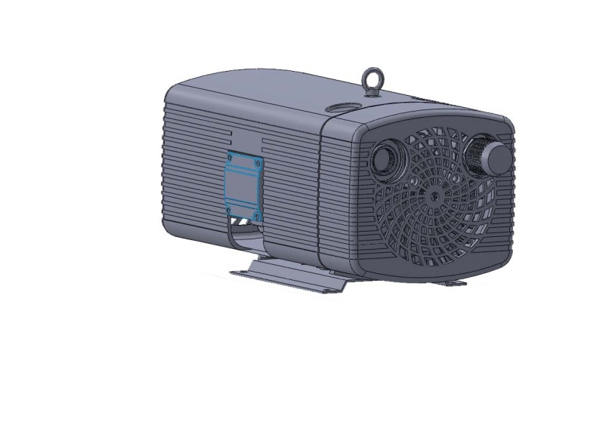

|  |  |  |  |  |  |
| --- | --- | --- | --- | --- | --- |
| **VD-C** | | **10** | **16** | **25** | **40** |
| (mm) | A | 200 | 200 | 200 | 200 |
| B | 225 | 225 | 225 | 225 |
| C | 10 | 10 | 10 | 10 |
| D | 87 | 87 | 159 | 159 |
| E | 160 | 160 | 190 | 190 |
| F | 190 | 190 | 220 | 220 |
| G | 3 | 3 | 3 | 3 |
| H | 195 | 195 | 245 | 245 |
| I | 37 | 37 | 37 | 37 |
| J | 54.5 | 54.5 | 70 | 70 |
| K | 109 | 109 | 140 | 140 |
| L | 111 | 111 | 132 | 132 |
| M | 99 | 99 | 126 | 126 |
| N | 25.5 | 45.5 | 45 | 45 |
| O | 108 | 133 | 126 | 158 |
| P | 141 | 166 | 168 | 200 |
| Q | 385 | 410 | 480 | 512 |
| R | G ¹/2 | G ¹/2 | G ³/4 | G ³/4 |
| S | 154 | 154 | 209 | 209 |

**零件分解圖 / Parts Illustration**



|  |  |  |  |  |  |
| --- | --- | --- | --- | --- | --- |
| 編號 | 零件名稱 | 編號 | 零件名稱 | 編號 | 零件名稱 |
| ITEM | PARTS NAME | ITEM | PARTS NAME | ITEM | PARTS NAME |
| 001 | 本體 Housing | 007-03 | 配線盒 Terminal box | 012-01 | O型環 O-Ring |
| 002 | 本體蓋 Housing cover | 007-07 | 配線盒蓋 Terminal cover | 013 | 壓力調壓閥 Pressure regulating valve |
| 003 | 馬達前蓋Front motor cover | 007-08 | 配線盒墊片 Terminal box washer | 014 | 出口消音器 Exhaust silencer |
| 004 | 馬達轉子 Motor rotor | 008 | 散熱風扇 Fan cpl. | 015 | 出口過濾器 Filter cartridge cpl |
| 005 | 轉子 Rotor | 009 | 腳座 Mounting plate | 016 | 波浪墊片 Ware washer |
| 005-01 | 葉片 Blade | 009-01 | 橡膠墊 Rubber mats | 017 | 過濾器 Filter cartridge cp |
| 005-02 | 墊片 Washer | 010 | 入口過濾器 Filter cartridge cpl. | 018 | 過濾器蓋 Filter cover |
| 006 | 外殼Case | 011 | 旋蓋 Screwed cover | 019 | 定位環 Tolerance ring |
| 006-01 | 外殼蓋Case cover | 011-01 | O型環 O-Ring | 020 | 吊環 Lifting eye |
| 006-02 | 橡膠墊Rubber mats | 011-02 | 彈簧夾 Spring | 021 | 前軸承 Front bearing |
| 007 | 馬達 Motor | 011-03 | 旋蓋 Screwed cover | 022 | 後軸承 Rear bearing |
| 007-01 | 馬達後蓋 Motor cover | 012 | 真空調壓閥 Vacuum regulating valve |  |  |

|  |  |  |  |
| --- | --- | --- | --- |
| **\* 訂購時請告知型號+零件編號 (例如:VD-C10+002)** |  |  |  |
| **\* Please notify model+parts item when you purchase.** | |  |  |
| **\*本公司保有設計變更之權利，恕不另行通知。** | | | |
| **\*We reserve the right to change the design without notice.** | | | |

***Dry running rotary vane pressure vacuum pump***

***VD-K Series***

|  |  |  |  |  |  |  |
| --- | --- | --- | --- | --- | --- | --- |
| **VD-K** | | | | **16** | **25** | **40** |
| 3~ | |  | 50Hz | G:\VD-K40.jpg200-240 / 345-415V ± 5% | | |
|  | 60Hz | 220-275 / 380-480V ± 5% | | |
| 1~ |  |  |  | 230V ± 10% (50 / 60Hz) | | |
| kW (3~) | |  | 50Hz | 0.55 | 1.10 | 1.85 |
|  | 60Hz | 0.65 | 1.30 | 2.20 |
| kW (1~) | |  | 50Hz | 0.55 | 1.10 | 1.85 |
|  | 60Hz | 0.65 | 1.30 | 2.20 |
| A (3~) | |  | 50Hz | 3.6 / 2.1 | 5.55 / 3.2 | 9.0 / 5.2 |
|  | 60Hz | 3.8 / 2.2 | 5.55 / 3.2 | 9.0 / 5.2 |
| A (1~) | |  | 50Hz | 5.0 | 6.60 | 10.50 |
|  | 60Hz | 4.5 | 7.90 |  |
| min¯¹ | |  | 50Hz | 1420 | | |
|  | 60Hz | 1700 | | |
| dB(A) | |  | 50Hz | 64 | 66 | 68 |
|  | 60Hz | 66 | 68 | 70 |
| kg | |  | 3~ | 21.4 | 31.5 | 39 |
|  | 1~ | 21.6 | 32.5 | 40 |

|  |  |  |  |  |  |  |  |  |  |  |  |  |  |  |  |  |  |  |
| --- | --- | --- | --- | --- | --- | --- | --- | --- | --- | --- | --- | --- | --- | --- | --- | --- | --- | --- |
| VD-K 16 | bar | S | 0 | -0.4 | -0.5 | -0.6 | 0 | -0.4 | -0.5 | -0.6 | 0 | -0.4 | -0.5 | -0.6 | 0 | -0.4 | -0.5 | -0.6 |
| D | 0 | | | | + 0.4 | | | | + 0.5 | | | | + 0.6 | | | |
| m³/h | S* | 15.6 | 11.81 | 12.1 |  | 14.6 | 11.7 | 10.6 |  | 14.3 | 11.1 | 10.0 |  |  |  |  |  |
| (50 Hz) | D | 16.5 | 12.5 | 11.6 |  | 15.4 | 11.3 | 10.3 |  | 15.0 | 10.8 | 9.9 |  |  |  |  |  |
| m³/h | S* | 18.8 | 15.4 | 14.5 |  | 17.7 | 14.0 | 12.7 |  | 17.2 | 13.2 | 12.0 |  |  |  |  |  |
| (60 Hz) | D | 19.7 | 15.5 | 13.9 |  | 18.5 | 13.8 | 12.4 |  | 18.0 | 13.1 | 11.9 |  |  |  |  |  |
| kW | 50 Hz | 0.55 | | | | | | | | | | | | | | | |
| 60 Hz | 0.65 | | | | | | | | | | | | | | | |
|  |  |  |  |  |  |  |  |  |  |  |  |  |  |  |  |  |  |  |
| VD-K 25 | bar | S | 0 | -0.4 | -0.5 | -0.6 | 0 | -0.4 | -0.5 | -0.6 | 0 | -0.4 | -0.5 | -0.6 | 0 | -0.4 | -0.5 | -0.6 |
| D | 0 | | | | + 0.4 | | | | + 0.5 | | | | + 0.6 | | | |
| m³/h | S* | 24.0 | 19.5 | 18.0 | 16.5 | 22.0 | 17.0 | 15.4 | 13.6 | 21.5 | 16.3 | 14.4 | 12.5 | 21.0 | 15.3 | 13.4 | 11.6 |
| (50 Hz) | D | 25.8 | 19.7 | 18.1 | 16.5 | 23.5 | 17.2 | 15.7 | 14.1 | 22.5 | 16.4 | 14.8 | 13.5 | 21.5 | 15.7 | 14.3 | 13.0 |
| m³/h | S* | 28.8 | 23.4 | 21.6 | 19.8 | 26.4 | 20.4 | 18.5 | 16.3 | 25.8 | 19.6 | 17.3 | 15.0 | 25.2 | 18.4 | 16.1 | 13.9 |
| (60 Hz) | D | 30.4 | 23.6 | 21.7 | 19.8 | 28.02 | 20.6 | 18.8 | 16.9 | 27.0 | 19.7 | 17.8 | 16.2 | 25.8 | 18.8 | 17.2 | 15.6 |
| kW | 50 Hz | 1.10 | | | | | | | | | | | | | | | |
| 60 Hz | 1.30 | | | | | | | | | | | | | | | |

|  |  |  |  |  |  |  |  |  |  |  |  |  |  |  |  |  |  |  |
| --- | --- | --- | --- | --- | --- | --- | --- | --- | --- | --- | --- | --- | --- | --- | --- | --- | --- | --- |
| VD-K 40 | bar | S | 0 | -0.4 | -0.5 | -0.6 | 0 | -0.4 | -0.5 | -0.6 | 0 | -0.4 | -0.5 | -0.6 | 0 | -0.4 | -0.5 | -0.6 |
| D | 0 | | | | + 0.4 | | | | + 0.5 | | | | + 0.6 | | | |
| m³/h | S* | 42.0 | 36.4 | 34.2 | 32.0 | 41.0 | 35.2 | 33.0 | 30.0 | 39.5 | 33.5 | 31.5 | 28.0 | 38.3 | 31.5 | 29.1 | 26.5 |
| (50 Hz) | D | 42.0 | 31.3 | 28.4 | 25.2 | 40.5 | 30.1 | 27.2 | 24.0 | 38.7 | 29.0 | 26.0 | 23.1 | 37.0 | 27.5 | 24.7 | 22.0 |
| m³/h | S* | 50.0 | 43.7 | 41.0 | 38.4 | 49.2 | 42.2 | 39.6 | 36.0 | 47.4 | 40.2 | 37.4 | 33.6 | 46.0 | 37.8 | 34.9 | 31.8 |
| (60 Hz) | D | 50.04 | 37.6 | 34.1 | 30.2 | 48.6 | 36.1 | 32.6 | 28.8 | 46.4 | 34.8 | 31.2 | 27.7 | 44.4 | 33.0 | 29.6 | 26.4 |
| kW | 50 Hz | 1.85 | | | | | | | | | | | | | | | |
| 60 Hz | 2.20 | | | | | | | | | | | | | | | |

S- Suction air / D-Compressed air

**VD-K**尺寸圖 / Dimensions**



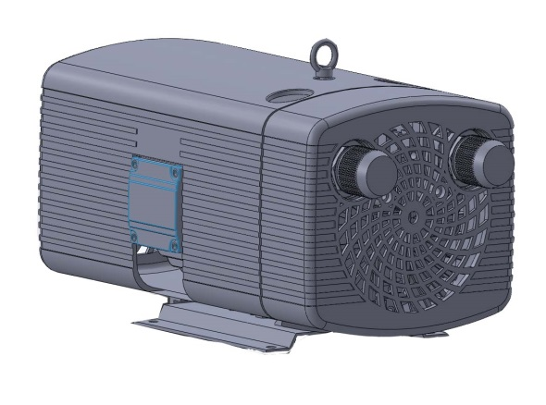

|  |  |  |  |  |  |
| --- | --- | --- | --- | --- | --- |
| **VD-K** | | **10** | **16** | **25** | **40** |
| (mm) | A | 200 | 200 | 200 | 200 |
| B | 225 | 225 | 225 | 225 |
| C | 10 | 10 | 10 | 10 |
| D | 87 | 87 | 159 | 159 |
| E | 160 | 160 | 190 | 190 |
| F | 190 | 190 | 220 | 220 |
| G | 3 | 3 | 3 | 3 |
| H | 195 | 195 | 245 | 245 |
| I | 37 | 37 | 37 | 37 |
| J | 54.5 | 54.5 | 70 | 70 |
| K | 109 | 109 | 140 | 140 |
| L | 111 | 111 | 132 | 132 |
| M | 99 | 99 | 126 | 126 |
| N | 25.5 | 45.5 | 45 | 45 |
| O | 108 | 133 | 126 | 158 |
| P | 141 | 166 | 168 | 200 |
| Q | 385 | 410 | 480 | 512 |
| R | G ¹/2 | G ¹/2 | G ³/4 | G ³/4 |
| S | 154 | 154 | 209 | 209 |

**零件分解圖 / Parts Illustration**



|  |  |  |  |  |  |
| --- | --- | --- | --- | --- | --- |
| 編號 | 零件名稱 | 編號 | 零件名稱 | 編號 | 零件名稱 |
| ITEM | PARTS NAME | ITEM | PARTS NAME | ITEM | PARTS NAME |
| 001 | 本體 Housing | 007-03 | 配線盒 Terminal box | 012-01 | O型環 O-Ring |
| 002 | 本體蓋 Housing cover | 007-07 | 配線盒蓋 Terminal cover | 013 | 壓力調壓閥 Pressure regulating valve |
| 003 | 馬達前蓋Front motor cover | 007-08 | 配線盒墊片 Terminal box washer | 014 | 出口消音器 Exhaust silencer |
| 004 | 馬達轉子 Motorrotor | 008 | 散熱風扇 Fan cpl. | 015 | 出口過濾器 Filter cartridge cpl |
| 005 | 轉子 Rotor | 009 | 腳座 Mounting plate | 016 | 波浪墊片 Ware washer |
| 005-01 | 葉片 Blade | 009-01 | 橡膠墊 Rubber mats | 017 | 過濾器 Filter cartridge cp |
| 005-02 | 墊片 Washer | 010 | 入口過濾器 Filter cartridge cpl. | 018 | 過濾器蓋 Filter cover |
| 006 | 外殼Case | 011 | 旋蓋 Screwed cover | 019 | 定位環 Tolerance ring |
| 006-01 | 外殼蓋Case cover | 011-01 | O型環 O-Ring | 020 | 吊環 Lifting eye |
| 006-02 | 橡膠墊Rubber mats | 011-02 | 彈簧夾 Spring | 021 | 前軸承 Front bearing |
| 007 | 馬達 Motor | 011-03 | 旋蓋 Screwed cover | 022 | 後軸承 Rear bearing |
| 007-01 | 馬達後蓋 Motor cover | 012 | 真空調壓閥 Vacuum regulating valve |  |  |

|  |  |  |  |
| --- | --- | --- | --- |
| **\* 訂購時請告知型號+零件編號 (例如:VD-K10+002)** |  |  |  |
| **\* Please notify model+parts item when you purchase.** | |  |  |
| **\*本公司保有設計變更之權利，恕不另行通知。** | | | |
| **\*We reserve the right to change the design without notice.** | | | |